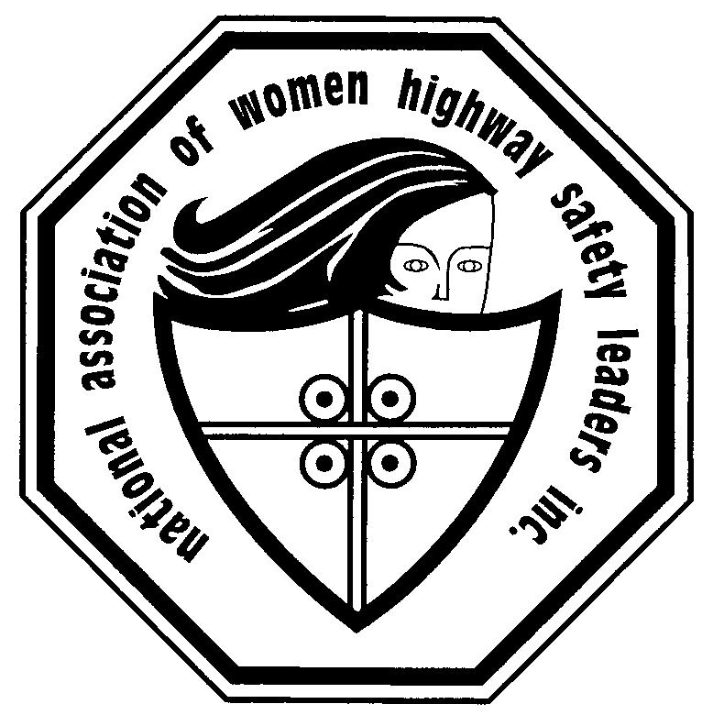
National Young Women’s Scholarship
in Traffic Injury Prevention

This Scholarship in Traffic Injury Prevention is funded by donations to the National Association of Women Highway Safety Leaders, Inc (NAWHSL) from private individuals, organizations, and governmental organizations to support young women who aspire to a career saving lives and preventing injuries on America’s roadways. Dr. David A. Sleet, a former Associate Director for Science in the Division of Injury Prevention at the Center for Disease Control and Prevention, and a plenary speaker at the 50th anniversary NAWHSL conference, initiated the scholarship to attract more young women into leadership positions in traffic safety. The scholarship recognizes, assists, and trains women working on practice-based projects or research in traffic injury prevention. The applicant can be studying at an accredited University, serving in an internship role, or as an employee in governmental or non-governmental organizations that support traffic safety initiatives.

Project Dates:
Application Period: September – December 31, 2022
Winner Announcement: January 20, 2023
Project Period: February 1 – August 1, 2023
2023 NAWHSL conference: August 9 – 12, 2023, Marriott Marquis, New York City, NY

Scholarship award includes:
- Award Certificate for NAWHSL’s National Young Women’s Scholarship in Traffic Injury Prevention
- $1,000 stipend
- Free one-year NAWHSL membership
- Complimentary registration at NAWHSL’s 2023 Annual Traffic Safety Leadership Conference
- The opportunity to display a poster and/or provide an oral summary on the project
- NAWHSL recognition at the annual meeting and in the program
- Announcement of award in the public media

Eligibility:
Applicants must be:
- A full-time female college student (9 credit hours or more) or an employee (20 hours or more/week) or intern, in an organization whose mission includes saving lives and preventing injuries on the road
- Age 30 or below and a U.S. Citizen
- Willing and able to attend the NAWHSL 2023 Annual Traffic Safety Leadership Conference, August 9 – 12, 2023, in New York City, New York.

Potential project topics:
- Vision Zero
- Drugs and Driving
- Alcohol-impaired driving
- Older Drivers
- Teen drivers
- Texting and Driving
- Helmet use
- Bikes, pedestrians, and motorcycle safety
- Occupant protection (seat belts and child restraints)
- Evaluation of a traffic safety program
- Driver risk and protective factors
- Road, vehicle, or environmental change (e.g. built environment or traffic engineering)

Project scope:
Projects may be related (but not limited to):
- Promoting traffic safety
- Identifying risk factors
- Public awareness (including use of social media and/or apps)
- Analyzing theory involving traffic safety
- Data collection and/or analysis of data (including survey)
- Intervention implementation and/or development

Post acceptance requirements:
- Sign a scholarship agreement
- Submit a project timeline
- Maintain a primary role in conducting the project
- Submit a final report to NAWHSL at the end of the project period
- Prepare and deliver remarks on the project for an oral presentation at the NAWHSL 2023 Conference to be held in New York City.

Application Materials:
- Current resume or curriculum vitae
- Application summary form (attached)
- Description of Project, 1000 words or less, double spaced, 12pt Times New Roman
  - Describe the need for the project and the target population
  - Identify goals, objectives and activities
  - Include time-line for project
  - Indicate an approximate numbers of individuals who will be impacted by the project
- One letter of recommendation from a faculty member or supervisor
- A second letter of support from your designated faculty member or supervisor who plans to mentor you on the proposed project

Review Criteria:
Project proposals will be reviewed by a NAWHSL Scholarship Selection Committee for their scientific and practical value, innovativeness, originality, and potential contribution to highway safety.
Applicants will be ranked according to:
- Addresses priority traffic safety issues
- Clear identification of the problem and/or rationale for conducting the project
- Description of the conceptual or practical value of the project
- Quality of writing
- Description of the methods used to implement the project
- Description of the potential contribution to saving lives and preventing injuries

Submit Application packet by email to Kay@MSsafety.com by December 31, 2022.

For Information contact:
Kay Brodbeck, National Association of Women Highway Safety Leaders
(601) 924-7815 or email Kay@MSsafety.com.

National Young Women’s Scholarship in Traffic Injury Prevention
Administered by: National Association of Women Highway Safety Leaders, Inc.
Application Summary Form
Applicant Name:
Address:
Phone:
E-mail:
Title of Project:
Brief Description of Project:

Scholarship Administrator Contact Information:
Kay Brodbeck, National Association of Women Highway Safety Leaders
(601) 924-7815 or email Kay@MSsafety.com.

